Subject: | Art
Grade Level: | 2nd
Title of Lesson: | Frog Life Cycle Sculptures
Standards: | VA.2.H.3.1: Describe connections made between creating with art ideas and creating with information from other content areas.  VA.2.S.1.4: Use accurate art vocabulary to discuss art.  VA.2.C.2.2: Identify skillful techniques used in works by peers and others.  VA.2.F.3.2: Work with peers to complete a task in art.  SC.2.L.16.1: Observe and describe major stages in the life cycles of plants and animals, including beans and butterflies.
Objectives: | Content:  - Students will create sculptures depicting the life cycle of the frog.  Language:  - Students will arrange their sculptures into the correct order of the life cycle and verbally identify them (one-word answer).  - Students will be able to verbally identify if an item is a sculpture.
Learning Strategies: | - Videos  - Pictures  - Realia  - Cooperative Learning  - “Gallery Walk”  - “Move-It”
Key Vocabulary: | - Sculpture  - Tadpole  - Life Cycle  - Froglet  - Tadpole with legs  - Frog Eggs  - Adult frog
Materials: | - SmartBoard to display a video  - Examples of sculptures  - Play-Doh  - Pictures of frogs at each stage of the life cycle  - Labels for each stage of the life cycle (eggs, tadpole, froglet, adult frog)
Stage of Language Acquisition: | Pre-Production (Level 1)
Motivation:  (building background) | - Have the students sit at their table in groups of 4.  - We will be completing a form of a “Gallery Walk”.  - Each table will have a different example of a sculpture, painting, drawing, and photo.  - Have four labels that say sculpture, painting, drawing, and photo.  - I will inform the students that there are four different kinds of art at their table and today they are going to identify and label those forms of art.  - Students will start at their table and put the labels next to the correct example.  - I will walk around and check each group’s answers.  - Then the students will rotate to the next table and repeat the process.  - They will do this until they have visited all 5 stations.  - The groups will then go back to their original table.
Presentation:  (comprehensible input, lesson delivery, use of learning strategies, HOT skills, interaction) | - I will now tell the class that we are going to be talking about sculptures today.  - I will ask each group to hold up the example of a sculpture that is sitting at their table.  - I will give the students 2 minutes to talk amongst their group and come up with a definition of sculpture in their own words.  - I will ask a member from each group to come up and write their definition of a sculpture on the SmartBoard.  - After we have a collective definition, I will display and read the correct definition of sculpture.  - I will walk to each table and hold the sculpture up for everyone to see and say, “This is a sculpture.”  - I will ask the students to repeat the word sculpture after I say it.  - I will show a video of a claymation of the frog life cycle: http://www.youtube.com/watch?v=FNd2z43Ofas&feature=related  - I will explain that the characters are created out of clay by an artist or artists. These artists create sculptures out of clay to make animations.  - I will let the students know that they will be creating their own sculptures of the life cycle of the frog.  - Before we can do this, we have to review the order of the frog life cycle.  - To do this, I will give each student in the group a picture with a different stage in the frog life cycle (tadpole, frog, froglet, eggs).  - They cannot show their group members what they got.  - I will show them a movement for each stage (Example: jump in place for adult frog, hands in a circle over head for eggs, swimming movement with hands up against body for tadpole, etc.)  - The students will get out of their desks and act out what stage they got and arrange themselves in the right order.  - There is no talking…..just acting!!!  - Once they have arranged themselves correctly, I will tell them they are right and to sit down and place their pictures in that order on their table.  - This will be their guide for creating their sculptures.
Practice and Application:  (meaningful activities, feedback) | - Now, the groups will begin making their sculptures.  - Each person in the group will be responsible for one part of the life cycle.  - They will form their sculpture out of clay and will have visuals to look at while forming their sculpture.  - I will go around and assist the students while they are forming their stage of the life cycle.  - When each member of the group has finished their sculpture, I will ask them to arrange them in the correct order of the life cycle.  - I will go around checking and giving feedback where needed.
Review and Assessment:  (review objectives and key vocabulary) | - To review, I will assign each student a number 1-4 at their table.  - 1 = eggs, 2 = tadpole 3 = froglet, 4 = adult frog  - When I call out the number, the person representing that number will stand up, hold up their part of the life cycle and say what it is in just one word.  - I will complete an informal assessment with the students after this review of vocabulary and objectives.  - I will hold up different items and ask for a “thumbs-up” if they are a sculpture and a “thumbs-down” if they are not a sculpture.  - Next, I will pick one group’s sculptures of the life cycle of the frog and hold up the frogs one at a time (out of correct order of the life cycle).  - I will ask the student to hold up one finger if it comes first in the life cycle, two fingers if it comes second in the life cycle, three fingers if it comes third in the life cycle, and four fingers if it comes fourth in the life cycle.  - From this, I can see which students have an understanding of our objectives and which students may need more review.
Extension: | Students could be given other medias to create frogs other than clay. Let them explore painting, drawing, and sculpture using resources they find outside (rocks, leaves, etc.) to create the frogs at their different stages.

Metal Sculpture
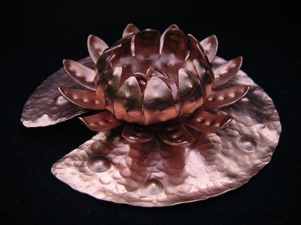

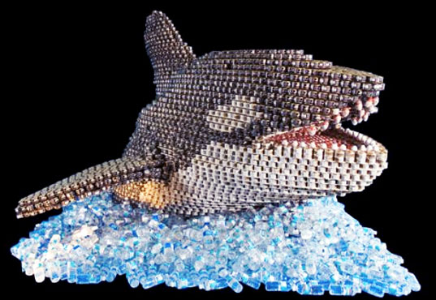
Sculpture made out of canned food.

Wood sculpture
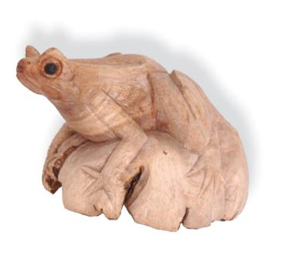

Copper Sculpture

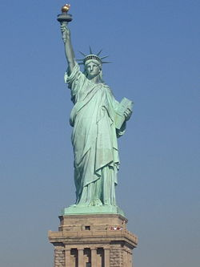

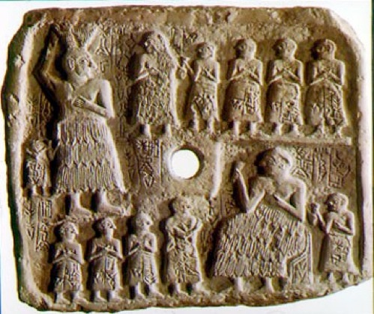
Sculpture used for storytelling.

.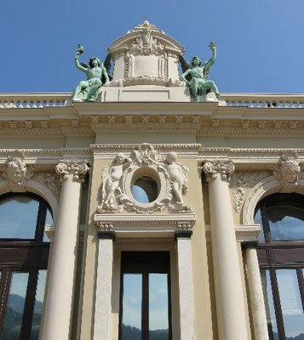
Sculptures used on buildings
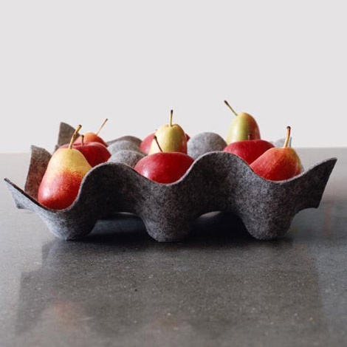
Sculpture used as a bowl.

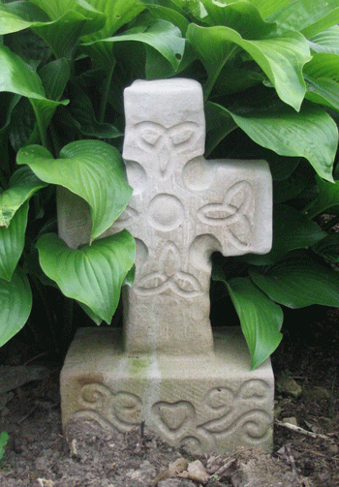
Sculpture used as a memorial or for religious purposes.

Pictures for grouping and labels

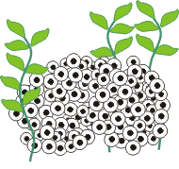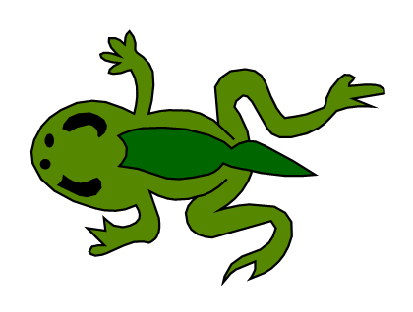

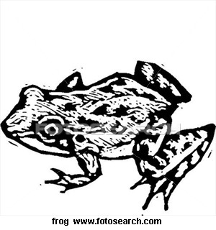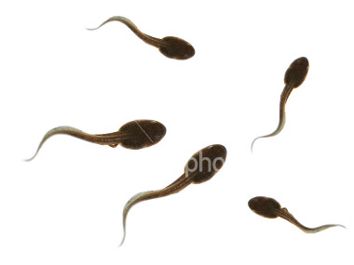

Eggs
Tadpole
Froglet
Adult Frog

