Subject: | Language Arts/Writing
Grade Level: | 2nd
Title of Lesson: | A Frog’s Tale
Standards: | SC.2.L.16.1: Observe and describe major stages in the life cycles of plants and animals, including beans and butterflies.  LA.2.1.6.1: The student will use new vocabulary that is introduced and taught directly.  LA.2.3.1.1: The student will pre-write by generating ideas from multiple sources (e.g., text, brainstorming, webbing, drawing, writer’s notebook, group discussion, other activities)  LA.2.4.1.1 The student will write narratives based on real or imagined events that include a main idea, characters, a sequence of events and descriptive details.  LA.2.2.1.2 The student will identify and describe the element of story structure, including setting, plot, character, problem, and resolution in a variety of fiction  LA.2.3.2.2 The student will draft writing by organizing details in a logical sequence that has a clear beginning, middle, and end and an awareness of audience.  LA.2.3.3.4 The student will revise by evaluating the composition, with the assistance of teacher, peer, checklist, or rubric.
Objectives: | Content:  Students will be able to identify and write about each stage of the frog life cycle using key vocabulary. (knowledge)  Students will create and develop a frog story using specific frog life cycle information. (synthesis)  Students will distinguish and point out elements of a story used in their frog story. (analysis)  Language:  Students will use story mapping, and pre-writing to create a frog story book.  Students will use specific key vocabulary and frog life cycle terms to include in their frog life cycle story.  Students will orally present their frog stories to the class identifying story elements used in story construction.
Learning Strategies: | - Find the Fib! Review game  - Book preview and story prediction using Charlie the Caterpillar  - Story map graphic organizer creation  - Story structure graphic organizer creation  - Storyboard illustration creation  - Writer’s workshop and peer feedback  - Cooperative learning  - Centers  - Student self evaluation
Key Vocabulary: | tadpole, froglet, hibernate, lifecycle, metamorphosis, frog eggs
Materials: | - Life cycle of frogs worksheet  - Charlie the Caterpillar by Dom Deluise  - Story map organizer  - Story structure organizer  - Storyboard organizer  - Typing paper (two for each student)  - Construction paper (one for each student)  - Rubber band or hair tie (one for each student)  - Markers and crayons
Stage of Language Acquisition: | Advanced (Level 5)
Motivation:  (building background) | - The teacher will review the life cycle of a frog and key vocabulary with students.  - Students will play a review game called Find the Fib. Students will be given three sheets of paper that have the following written on them: 1 is a Fib!, 2 is a Fib!, and 3 is a Fib!  - The teacher will read aloud three statements about the life cycle of the frog. Students must decide which of the three statements is a fib. When they are ready to answer, they will stand up and show the paper with the number of the fib.  - The teacher will provide the students with a worksheet of the life cycle of frogs.
Presentation:  (comprehensible input, lesson delivery, use of learning strategies, HOT skills, interaction) | Day 1  - The teacher will tell students that they are going to write a creative story about the life cycle of the frog. They are going to pretend that they are the tadpole that hatched from the egg and describe what they see, feel, and the changes they go through while growing into an adult frog. The book will include accurate frog cycle information and vocabulary but may include other aspects (such as characters, setting, etc. that are fictitious or fake).  - The teacher will tell students that they will review parts of the book by reading and then filling in a story map graphic organizer.  - The teacher will introduce the book Charlie the Caterpillar by Dom Deluise. This story was picked instead of a frog story as not to sway student’s story.  - Students will preview the story by looking at the front and back cover of the book.  - The teacher will ask students to predict what they think the story will be about. Students will share their predictions with their shoulder partners.  - The teacher will read the story to the students. After reading, the teacher will review parts of a story using the book and will fill in a story map graphic organizer using the smart board. The following information will be discussed:  - Title-name of story  - Students will brain storm titles that they may be able to use for their frog story.  - Let students know that most authors don’t think of a title to their story until the story is written.  - Characters-people or creatures in the story  - Will the tadpole (the main character) be the only character in your story?  - Students will brainstorm characters that they may include in their story.  - Setting-where and when does the story take place  - Think of unusual places as well as common places that your character may be.  - Plot- the story itself. A good plot captures the reader’s attention and makes them want to keep reading.  - Part of the part will include the tadpole going through life cycle changes and becoming a frog.  - Conflict and conflict resolution will also be part of the plot.  - Conflict-a problem the character faces in the story.  - The character may have conflict with other creatures in the pond, humans, the weather, etc. (external conflict)  - Students will brain storm ideas for a conflict in the story they will create.  - The character may also have a struggle that happens inside his/her head (internal conflict). An example would be if the frog in your story is insecure because of the bodily changes he/she is going through.  - Conflict resolution-how the problem is solved.  - Students will brainstorm how they will solve the problems in their story.  - The teacher will complete the story map graphic organizer and will leave the map on the smart board so students may use it as an example.  - The teacher will give each student a story map graphic organizer. Students will write the setting, characters, problem, solution, and ending of their story. Students may use their science notebooks, frog life cycle worksheet, and science text book while constructing their story.  - The teacher will circulate around the room and answer any questions students may have.
Practice and Application:  (meaningful activities, feedback) | Day 2  - The teacher will have students take out the story maps they worked on the previous day. The teacher will tell students that all stories must have a beginning, middle and end. The teacher will display a story structure graphic organizer on the smart board.  - The teacher will refer to the Charlie the Caterpillar book introduced the day before. The teacher will ask students what happened in the beginning of the story. She will write the student’s answers down in the box labeled beginning. She will repeat this procedure for the middle and end boxes.  - On the board, the teacher will write the following information for students: beginning-introduce characters and setting, middle-the plot and conflict, end- conflict resolution and conclusion of the story.  - Students will be given a story structure handout. They will use this to fill in the beginning, middle, and end of their frog story. The teacher will circulate around the room and answer any questions students may have.  - The students will be separated into groups of four. Groups will be determined the teacher. ELL students may be placed in a group with their peer buddy.  - Students will be participating in a mini writer’s workshop. They will share their story structure with the students by reading it aloud. Students will then be given the opportunity to give the student feedback. The teacher will instruct students to be positive and respect the writing of their classmates.  - Students will be given time to rewrite and edit their stories.  - Students will be turning in their story structure worksheets so the teacher may check their frog life cycle accuracy. She/he will return them on day 3.  Day 3  - The teacher will inform students that they will be working in three story centers today. They will rotate among these centers. The teacher will circulate among these centers to help students and answer any questions that they may have. Examples of final works will be provided at each center so students may see what their final product should look like. By the end of the day, they will have a published frog story book.  Center 1  - Students will be given a storyboard worksheet which they will use to illustrate the major events in their story. Students may use their textbook and frog life cycle worksheet to help with their illustrations.  Center 2  - Students will be constructing their book at this center. They will be provided with blank two sheets of blank typing paper, one piece of construction paper, a rubber band (or hair tie), and a pair of scissors.  - Students will place the construction paper on the bottom, put the two typing paper sheets on top, and fold in half. Students will then cut a small slit at the top of the fold and one at the bottom. The rubber band will be placed along the folded area, creating a book.  Center 3  - Students will be filling in the writing and illustrations in their books. They will be provided with markers and crayons.
Review and Assessment:  (review objectives and key vocabulary) | Review  - Students will present their frog story books to the class. Before reading their Story, they will describe the parts of their story (characters, setting, and conflict).  - Students will read their story.  - Students will get the opportunity to give positive comments about their peers Story.  - Students will assess their own story creation performance. They will answer the following questions after they present their stories:  - Write something you enjoyed about writing this story.  - Write something you didn’t like about writing this story.  - Write something that you learned while writing this story.  - Write something you would like to learn about writing a story.  Assessments:  - Students will be assessed using informal observation during discussions and while walking around the classroom and during the centers activity.  - Students will be authentically assessed by the completion of the story map, and story structure worksheets. The teacher will check for frog life cycle accuracy, that key vocabulary has been used correctly, and that the main parts of the story have been added.  - Frog stories will be formally assessed using a rubric. (final summative assessment)
Extension: | Students may be given an opportunity to use their frog story to perform in a reader’s theatre. Students could pick four stories (by voting) written by students and will be placed in four different groups. Using the story that their peer created, groups will decide which characters that they will perform during the theatre. Students will be given time to practice, create costumes and add to their scripts. The theatre could be performed for the class or other classes in the school.

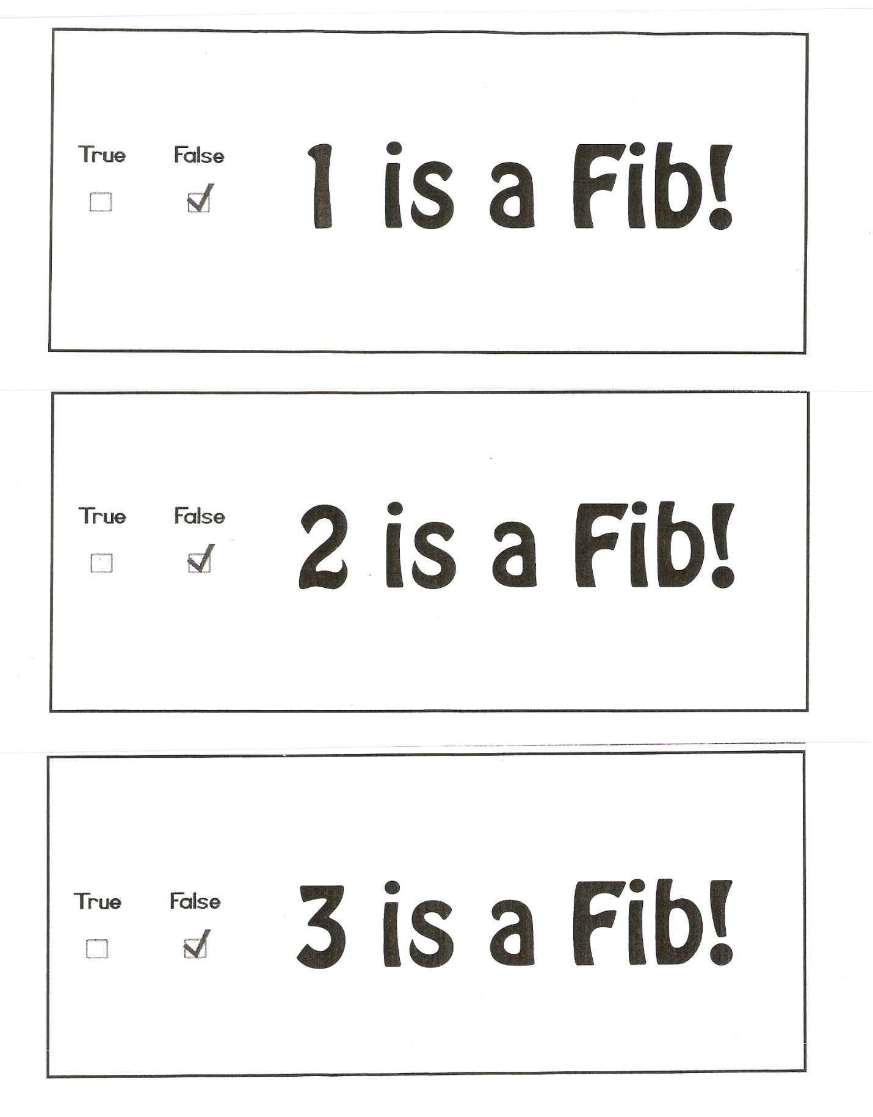
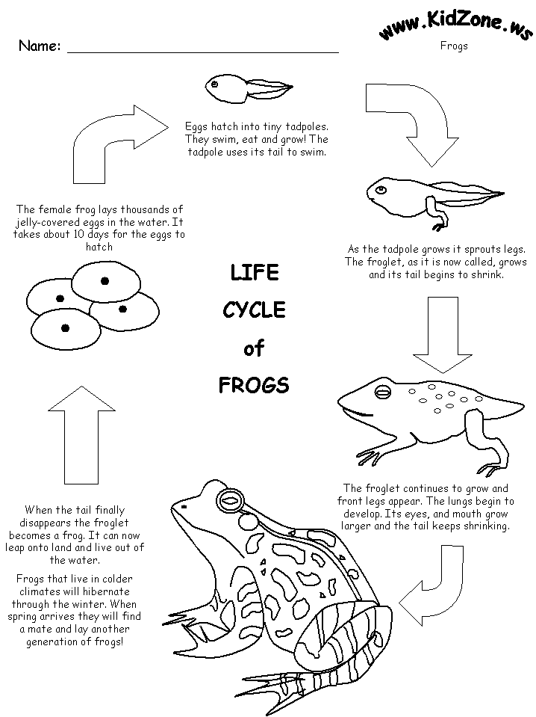
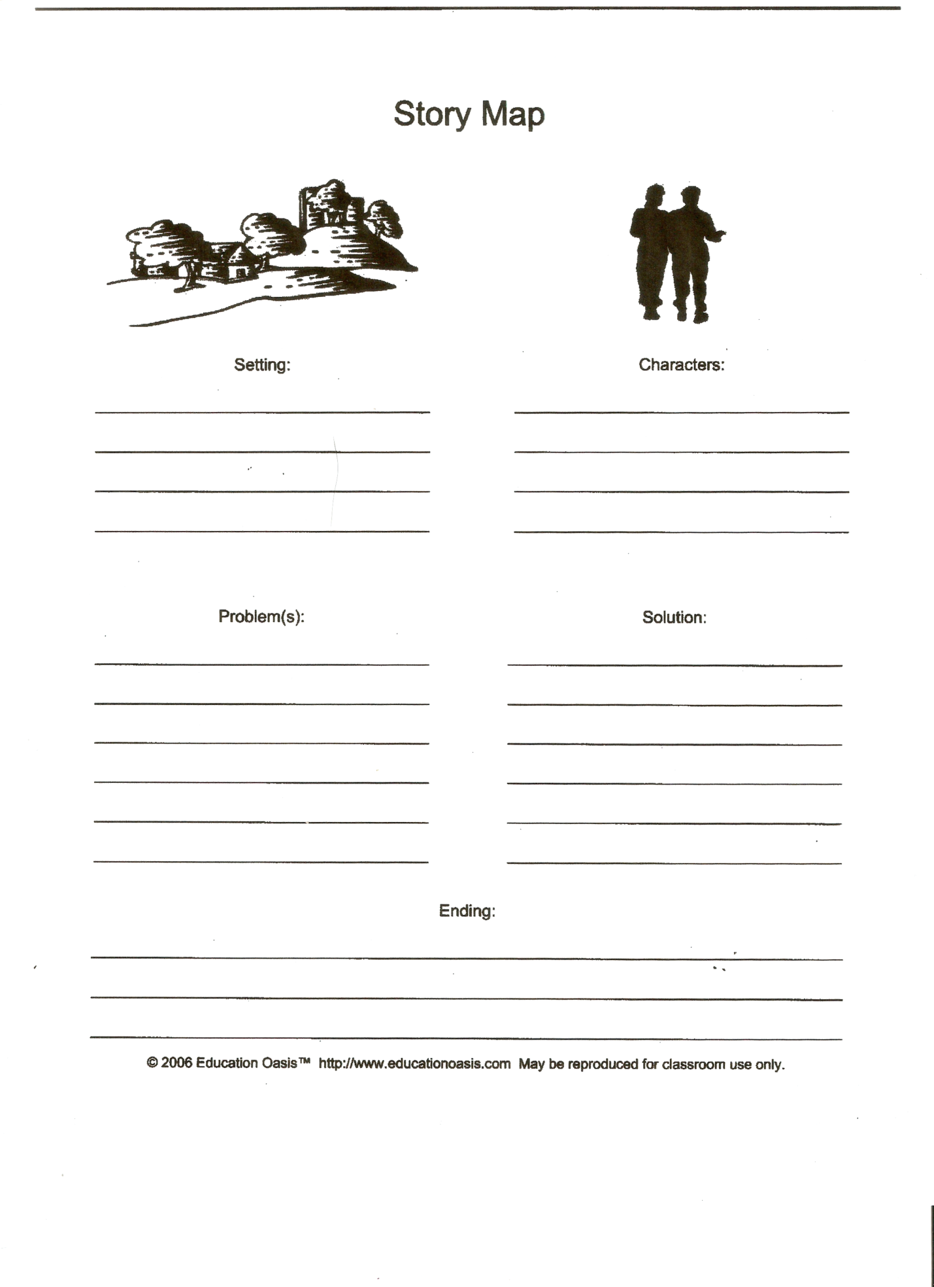
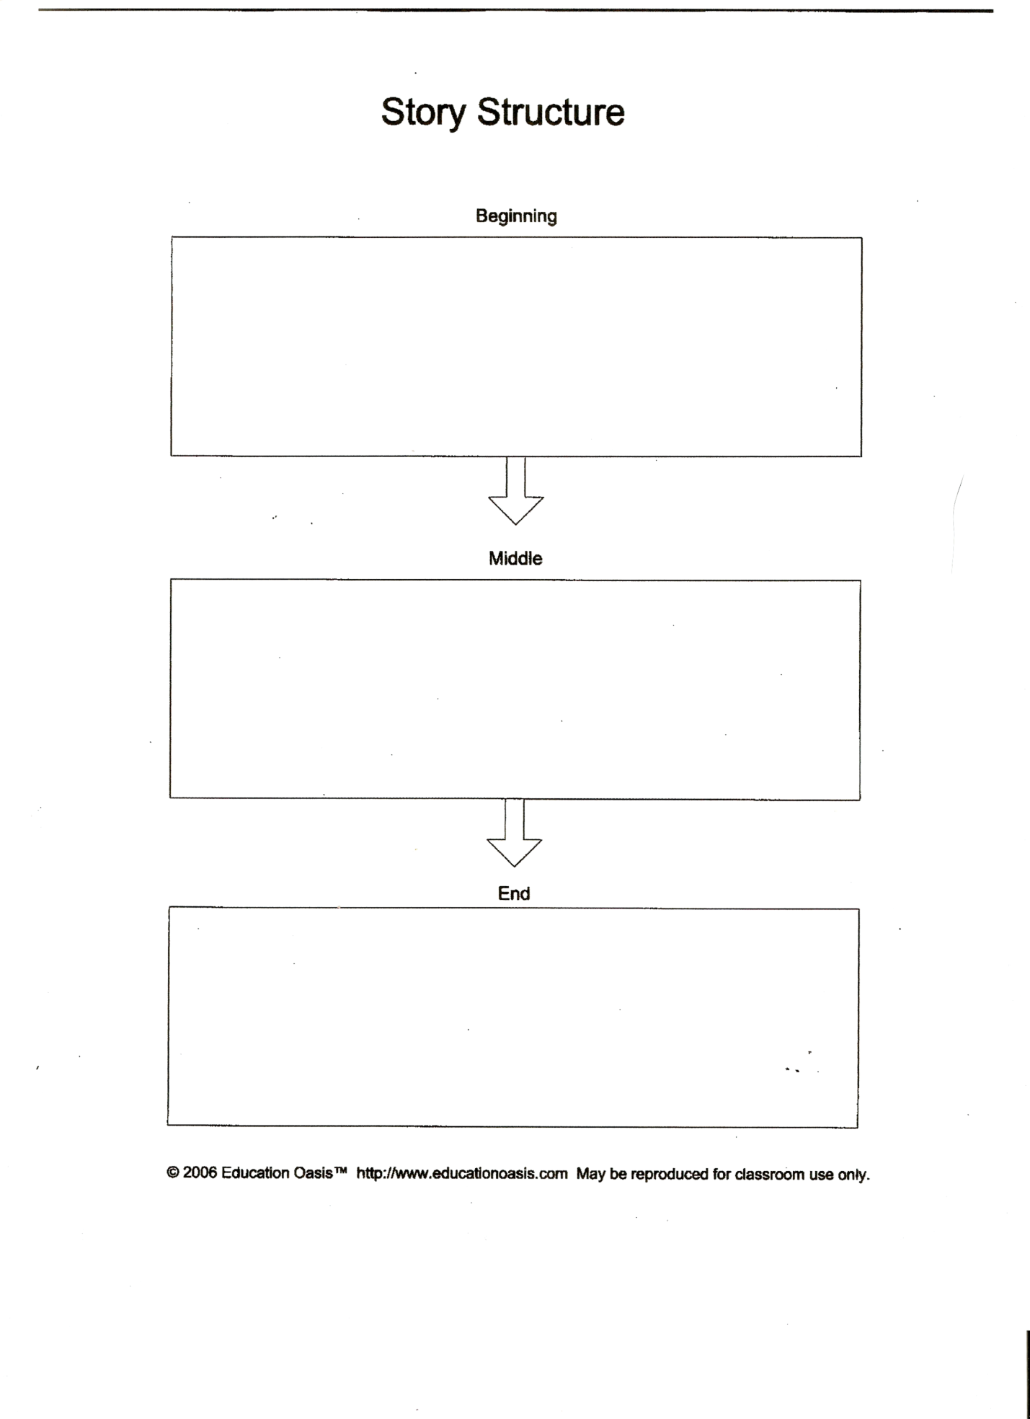

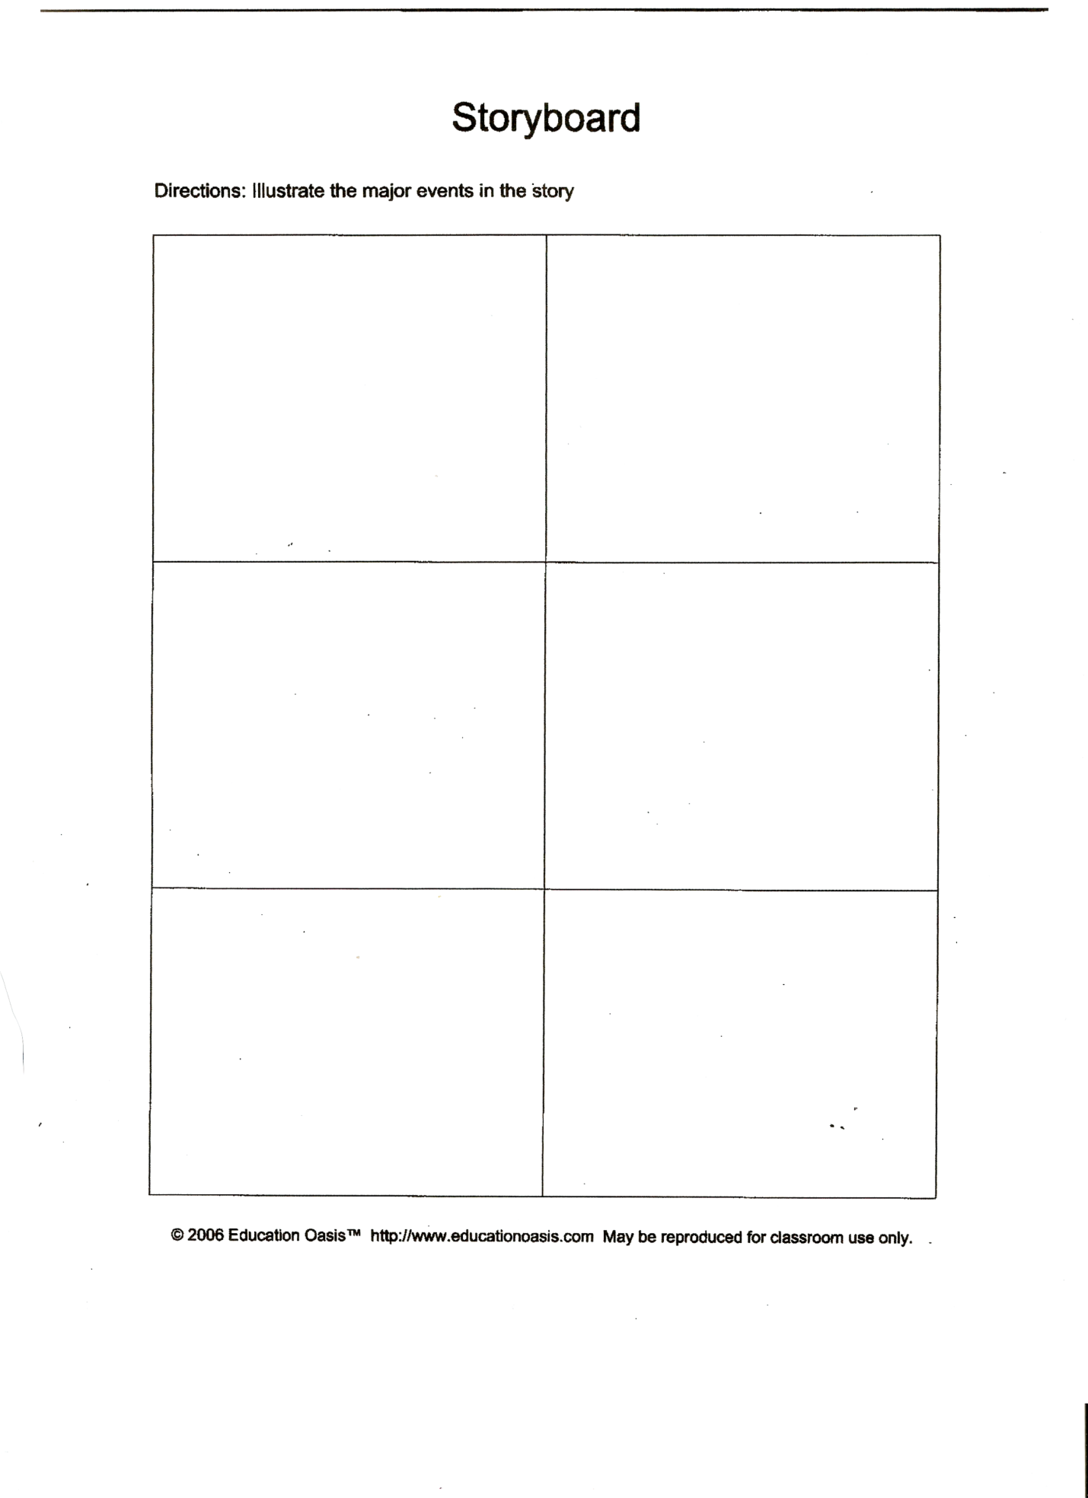

Frog Story Rubric
 | 3 | 2 | 1
Use of life cycle vocabulary words in their Frog story. | Student uses all life cycle vocabulary words correctly in the story. | Student uses some life cycle vocabulary words correctly. | Student does not use life cycle vocabulary words correctly.
Elements of a story: plot, setting, character, a problem, and a resolution. | Student uses all story elements: character, setting, plot, problem, and a resolution in their story. | Some of the elements are used in the student’s story but some elements are unclear or missing. | The student uses very few or no elements of a story.
Story includes a clear beginning, middle, and end. | Students clearly write a beginning, middle, and end to their story | A few things seem to be out of order in the student’s story. | The student’s story does not have a clear beginning, middle, or end.
Use of frog life cycle steps in their frog story. | All frog life cycle steps are included and are in the correct order. | Most of the frog life cycle steps are included in the story and some are in the correct order. | Few or no frog life cycle steps are included in the story and are not in the correct order.
Use capitalization and punctuation marks. | All capitalization and punctuation marks are used correctly. | There were a few capital and/or punctuation errors. | There were many capital and/or punctuation errors.

